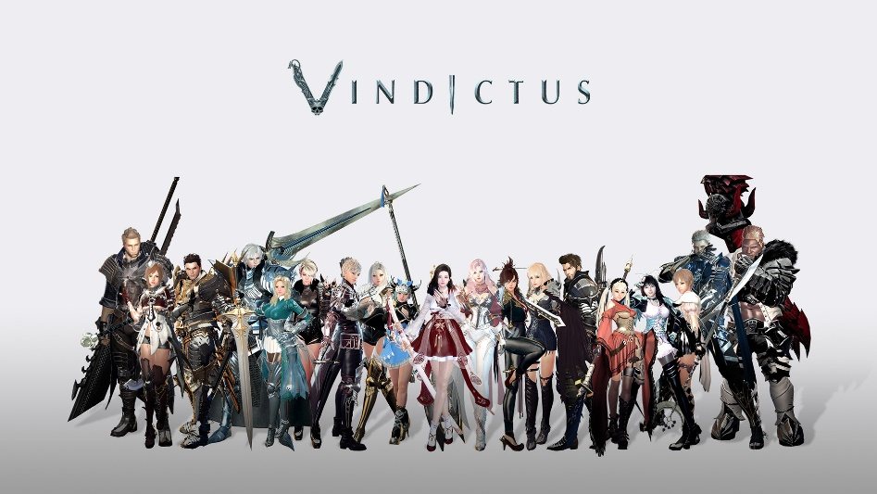

About This Game:

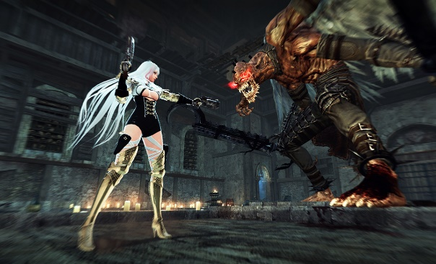

Vindicates is an action massively multiplayer online role-playing game created by dev CAT, an internal studio of Korean free-to-play game publisher Nexon. Vindicates is a prequel to the MMORPG Mabinogi and is known as Mabinogi Heroes in Asia. [Wikipedia](https://en.wikipedia.org/wiki/Vindictus)

**Developers:**[Nexon](https://www.google.com/search?sa=X&bih=730&biw=1498&rlz=1C1UEAD_enPK1023PK1023&hl=en-US&q=Nexon&si=AEcPFx7HnMxbNS2egwqbd2fGseeWkZi3ZCVlQ3vY-NLoLE7SWY2TSBgmXrm6MsqUMyhE1AjaqIf_xPm_f0muoYMAbuLCRB2zZCRgguMfKdDxNg3jgxu7XNrgvaqjyCu1rKAoRtCC2D-lnDSNoXbWRXWxIoYxy3HqW6t_UvrWTaVONKFwQwEWBv5sZUigF8BYUs58YPAedQRlzSGzjjH8j1gKht5ws_Sy5KZ9YiKff02X00YbfCq7txSx3lpGbLWvWthj0PYQ-C_AZVepCiqdYn2A6Qj6oT0m3w%3D%3D&ved=2ahUKEwjUgfT5tfP8AhVEU6QEHflxDisQmxMoAHoFCJMBEAI&cshid=1675223642120068), [dev CAT studio](https://www.google.com/search?sa=X&bih=730&biw=1498&rlz=1C1UEAD_enPK1023PK1023&hl=en-US&q=devCAT+studio&si=AEcPFx6JXutHkM717ja3aO41YP5w59cvuIQ168G5lhV1D2WrybGQUoWE0bT6x5AkdaEGgx3Di82qfh40NJ0JFRIXoWPblGUTU3rtsIijydb67qZfRqq-gBzFQIthyo9N_QuJCs7PoAuhNHICbe-OO4DtIUC49SQ3ZrCE5VJDXYv9-YASOzVDfIR-wm3ORkj6REJQPymNqt3JFW5277aMxzhsnMb1AwHK8PonWAsswZvshyrn28_TQ9v_zHkKd2SKiK-DQ6CnOJNwtmNIP383elp2eovpQ1nElEBoNC5P76k8E5g7pa8gp-A%3D&ved=2ahUKEwjUgfT5tfP8AhVEU6QEHflxDisQmxMoAXoFCJMBEAM&cshid=1675223642120068), [dev CAT](https://www.google.com/search?sa=X&bih=730&biw=1498&rlz=1C1UEAD_enPK1023PK1023&hl=en-US&q=devCAT&si=AEcPFx7eHRJU0tWbjC5cc2C2rVygfPuoetC2JDc0IDqLp89f-IaLMh-4OItUvR94YjwRTbdo5A2xwsVbDD5P86KiC3urO7lQKju6rUEeCp5x4lAs-coWSOAPxOgV7DrPKAjHywN-s23cv-MTuJS-ybVJ3wuYpAUL_rdDcuy29T-bY-Y__CCsnFHT2a7l1mzPLqJaNXxZ7KAvopDUxoc6ttcKyANRdUt_OMnBSLfdQgacYYBqTUMh0Yw5-GY2wundQIlEcxUSiV-f500BL7VupXJonTk5Wl9VWw%3D%3D&ved=2ahUKEwjUgfT5tfP8AhVEU6QEHflxDisQmxMoAnoFCJMBEAQ&cshid=1675223642120068)

**Engine:**[Source](https://www.google.com/search?sa=X&bih=730&biw=1498&rlz=1C1UEAD_enPK1023PK1023&hl=en-US&q=Source+(game+engine)&si=AEcPFx5y3cpWB8t3QIlw940Bbgd-HLN-aNYSTraERzz0WyAsdBpQ-Cly0Th0uSBqjarIE5lbY-K0CN39OFK3pxGiVTl8id4BFAY-5y_JBbD3JBYnYd_Sr_6vqQRE8H5LYsNLArI6OSlYnh2d0UUlnv_rSFVQfqK83lgININBlMhXXulPW8zKcYWosMapYVeZJUCgQGIPIoRJwOFdh3RhTnb2g2sm8bm4gQ%3D%3D&ved=2ahUKEwjUgfT5tfP8AhVEU6QEHflxDisQmxMoAHoFCJEBEAI&cshid=1675223642120068)

**Platform:**[Microsoft Windows](https://www.google.com/search?sa=X&bih=730&biw=1498&rlz=1C1UEAD_enPK1023PK1023&hl=en-US&q=&si=AEcPFx6l3RvH8SFlhHZyn7jIc6m2bU9vmoFvFAMQv2WWSYjXN2hvqljN2BOEvYj7rgK60JuWtAM0u4ROF0iIleHFNLMZ5O9Z5adL-jskLsdamBXRXaKAw7JdH1GIcGrLve_0tcW_g8eXJ_eNwkFFn754sKeid4I49BEkCx8wbzIIGEfJwMvmc-c%3D&ved=2ahUKEwjUgfT5tfP8AhVEU6QEHflxDisQmxMoAHoFCKYBEAI&cshid=1675223642120068)

**Publishers:**[Nexon](https://www.google.com/search?sa=X&bih=730&biw=1498&rlz=1C1UEAD_enPK1023PK1023&hl=en-US&q=Nexon&si=AEcPFx7HnMxbNS2egwqbd2fGseeWkZi3ZCVlQ3vY-NLoLE7SWY2TSBgmXrm6MsqUMyhE1AhTBwNtLBk4IezFB4m5C541Uep-15YNdUNyvTv3bvx1XPqJ7WZ777J0P4Zi67ZKzGiCcV-k2x9g8TAia4R2BKA_Tdd5m_e1nD4Vz7RT-YdP4vFUmTs_HkklsA1mZUFa5kypnfIKRH-Xc4ib3Ah8Rhtdpok8KwxSdmdNE5j1qZ8GGU0Baecb-0dvAGJJiumf0YevyDBi&ved=2ahUKEwjUgfT5tfP8AhVEU6QEHflxDisQmxMoAHoFCKUBEAI&cshid=1675223642120068), [Tiancity](https://www.google.com/search?sa=X&bih=730&biw=1498&rlz=1C1UEAD_enPK1023PK1023&hl=en-US&q=Tiancity&si=AEcPFx7eHRJU0tWbjC5cc2C2rVygfPuoetC2JDc0IDqLp89f-Hl1km6tRgkxirU7C9vUmiid3PhnM3XOhhZDkJ6u7QTbNpLzzJukACNy8hFDZAsnpkLq78m7LXylAwSF__igeDKXbEovtZNKQkhzim_KO8A8aOq-qXdsWhtRWZXtFi3Vu6MkEW1OyKwyK0mI7NK72me-MMCZussDv3mohH3yfFjYwvaq3sQHUAmSjePHUHijiGewQxlnQNWP111UdWchzzq07n3h&ved=2ahUKEwjUgfT5tfP8AhVEU6QEHflxDisQmxMoAXoFCKUBEAM&cshid=1675223642120068), [NEXON Korea Corp. & NEXON America Inc.](https://www.google.com/search?sa=X&bih=730&biw=1498&rlz=1C1UEAD_enPK1023PK1023&hl=en-US&q=NEXON+Korea+Corp.+and+NEXON+America+Inc.&si=AEcPFx7eHRJU0tWbjC5cc2C2rVygfPuoetC2JDc0IDqLp89f-NBp1nUiltf1I_7pVgikgiYhu3iUqOIf7ur5F3Bj1_FPem7v75g9l1bhHhQQquROAlrLeEx7annjo44EpzryPmixiSm5MfdAas5Fpf7fCvaGJ6Nk7-SCOufSCls2WQG9k9fHUUpkoRTkUNnh80-OHbr8RIuJoSpEea4GJE9BjJC_lkX5XAmDDhgYqLGQCBZ7N7mLAkLDwPmAch_l2_eu2EAw3cAKJy4opqyeMGTagn-gmsFKskgjVSoo5moxYvaucPEtmC4%3D&ved=2ahUKEwjUgfT5tfP8AhVEU6QEHflxDisQmxMoAnoFCKUBEAQ&cshid=1675223642120068)

**Initial release date:**January 21, 2010

**Mode:**[Multiplayer video game](https://www.google.com/search?sa=X&bih=730&biw=1498&rlz=1C1UEAD_enPK1023PK1023&hl=en-US&q=Multiplayer+video+game&si=AEcPFx5y3cpWB8t3QIlw940Bbgd-HLN-aNYSTraERzz0WyAsdEYnzlnfjzOkOOGzw7gnFGl7_j2ueQkDQwSGNgJhUbsLZCS6QIlLbsTvUPU_aa1RzOxSnEgJf2xUtlnlzMGTOmc6mCwrOxfhELiXC6A_COZDuWnhzr4juGosj4zmtUURH9qI7l6SwPlcPoFNlONTX7pmjkMpBZfYrqhGtk1aJIsYvIX8Pg%3D%3D&ved=2ahUKEwjUgfT5tfP8AhVEU6QEHflxDisQmxMoAHoFCKMBEAI&cshid=1675223642120068)

**Genres:**[Massively multiplayer online role-playing game](https://www.google.com/search?sa=X&bih=730&biw=1498&rlz=1C1UEAD_enPK1023PK1023&hl=en-US&q=&si=AEcPFx6l3RvH8SFlhHZyn7jIc6m2bU9vmoFvFAMQv2WWSYjXNwJCuxDNISZEfIaQ413FzjD6vZ2FTN4YJYryhjONs2nWzdC1EmJkWnKmvxne1b6cBUuuq30VV_qynKyz8Z4MxVlrz0gUW6YjzFi_d6lsZxh6-zFjbgo6KZXkDqyhTLdV8Y1PprLmx0dqyX48n1L6em9_81Fz6U7g7UgisSOLpY9qglJvzGzdFAUkHPgYd6E_sHGKvdAdI5ZxfwmxOz4481vTYxRe&ved=2ahUKEwjUgfT5tfP8AhVEU6QEHflxDisQmxMoAHoFCKcBEAI&cshid=1675223642120068), [MORE](https://www.google.com/search?sa=X&bih=730&biw=1498&rlz=1C1UEAD_enPK1023PK1023&hl=en-US&q=vindictus+genres&stick=H4sIAAAAAAAAAOPgE-LSz9U3MC0wMcpO01LJTrbSTy5L10_Ozy0oLUktii_LTEnNT0_MTbUCCsenp-YVpS5iFSjLzEvJTC4pLVYAixQDADPghe5HAAAA&ved=2ahUKEwjUgfT5tfP8AhVEU6QEHflxDisQ44YBKAF6BQinARAD&cshid=1675223642120068)